**USE CASE DIAGRAMS**

* Background:

After finishing the first draft of the requirements, we started working with the diagrams and especially with behavioral diagrams. This week, we finished use case diagrams, where I had to finish 3 of them: one for the administrator, one for the customer and one for the supplier and their relationships with every other element of the website.

* Work done

1. Administrator Use Case Diagram

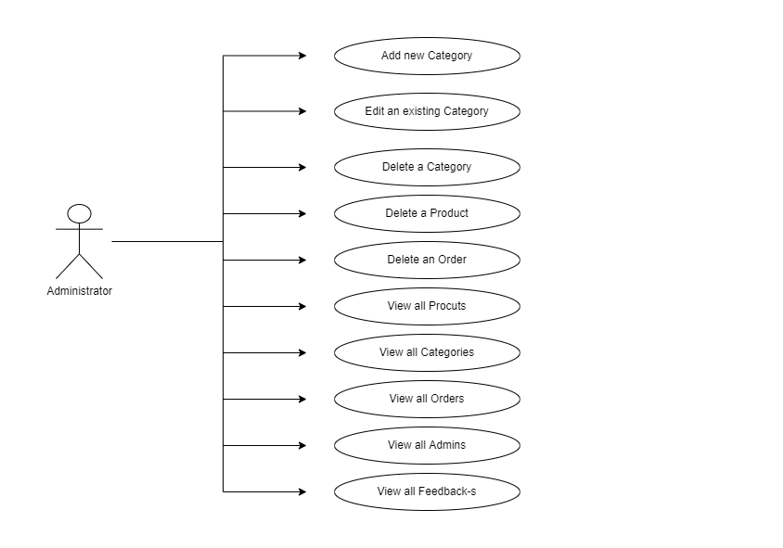

The administrator has all CRUD operations clearly visible. He/she can view all categories, products, orders, admins and feedbacks and at the same time can add new categories. Deleting operation is performed for categories, products and orders. Editing operation is performed for category.

1. Customer Use Case Diagram

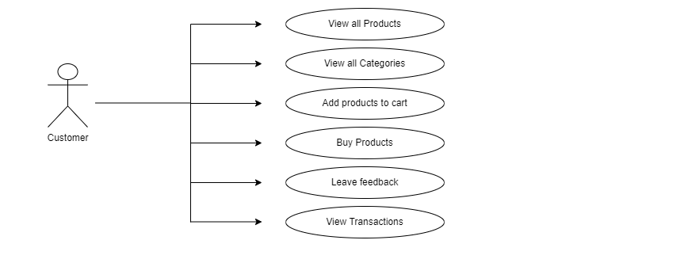

A customer can view all products, categories and transactions. Furthermore, the customer can add products to cart, buy them and also leave feedbacks.

1. Supplier Use Case Diagram

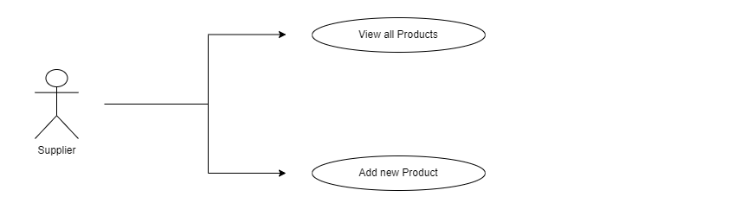

A supplier is responsible only for the products, so he can view all products available in the system and also add products.